Acceptance App

Overview: The Acceptance App is designed to ensure uninterrupted order management when the primary server or POS system is unavailable.

In situations such as a server failure, power outage, or when the main system is inaccessible, outlet staff can continue managing online orders directly from a mobile device.

Using the Acceptance App, you can:

- Accept and manage incoming online orders using a mobile phone.
- Continue receiving orders even if the outlet's server or POS system is not operational.
- Turn individual menu items ON/OFF to control item availability.
- Open or close the outlet by changing the Store ON/OFF status.
- Maintain smooth restaurant operations without depending on the main system.

This application helps prevent order loss, improves business continuity, and ensures customers can continue placing orders during unexpected system downtime.

Installation Step :
Path : billing.petpooja.com >> Setting >> Petpooja Apps >> Online Order Acceptance
Dashboard Link : https://billing.petpooja.com/users/petpooja_application

Step to reach Online order acceptance app

Step 1: billing.petpooja.com in step to reach Online order acceptance app : Open your browser and go to Billing.petpooja.com.

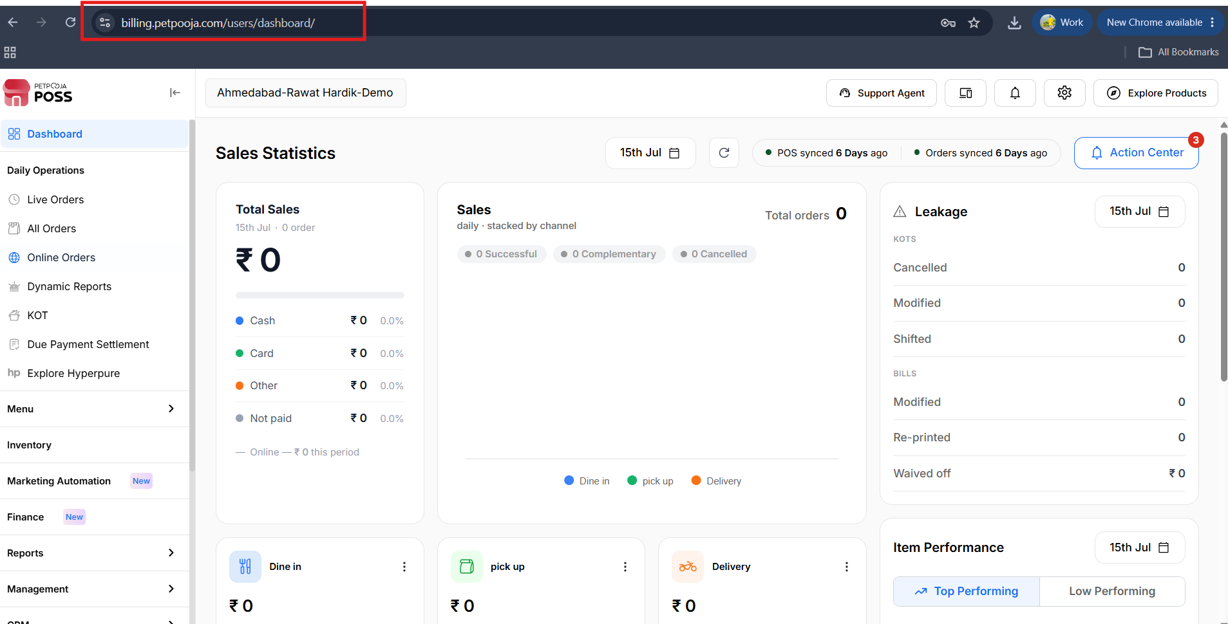
{ Image Name: PetPooja Dashboard,
Description: The highlighted URL indicates that this is the billing.petpooja.com.Here is an image of step 1 Billing.petpooja.com in Steps to Petpooja Apps }
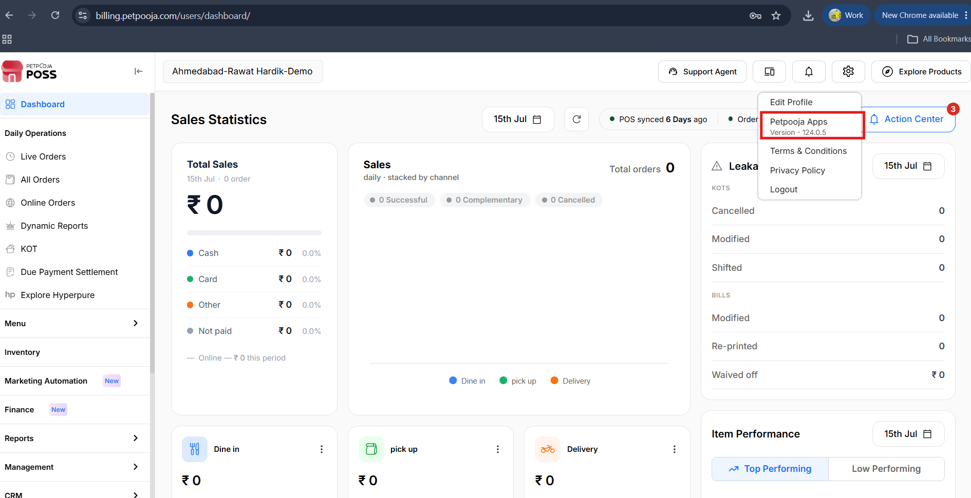
{ Image Name: Petpooja Apps,
Description: The highlighted option show how to reach petpooja App under the setting option click on “Petpooja Apps”
Step 2 : Configuration to reach Petpooja App : Click on Right side top setting option click on it after that there show petpooja app option click on it.}
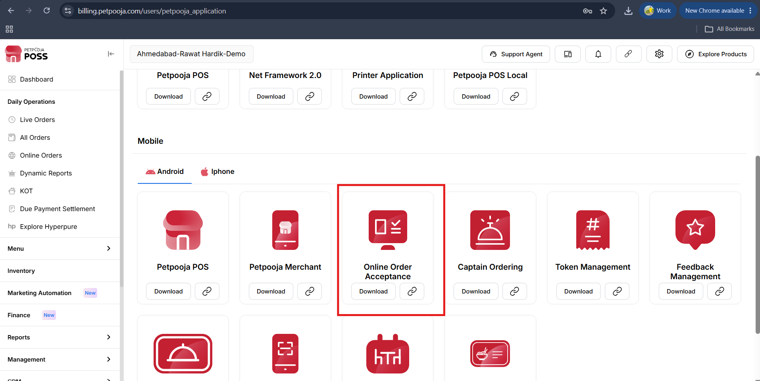
{Image Name: Petpooja Apps,
Description: The highlighted option shows how to reach an online order acceptance app and get the link or download from the merchant app directly.
Step 3 : After clicking on the Petpooja App, you will see a list of all available apps. Select the "Online Order Acceptance" app. From there, you can copy the link and send it to your mobile using WhatsApp. If you are already using the Merchant App on your mobile, simply click on "Download" to install the Acceptance App directly. }

Step 4 : After successfully installation show mapping screen on Acceptance app }
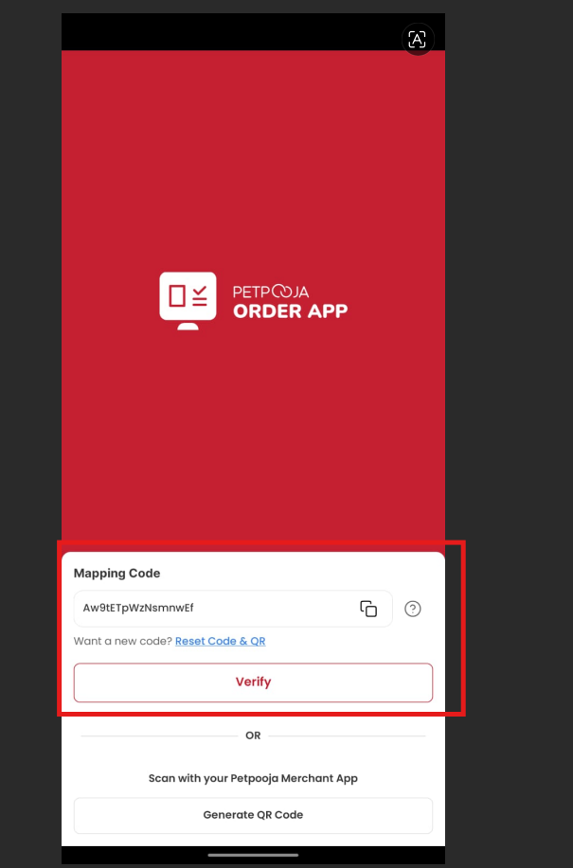

{Image Name: Mapping screen,
Description: The highlighted option show wich type of mapping screen and map code in acceptance app,
Step 4 : After successfully installation show mapping screen on Acceptance app }

Step 5 : After that, go to billing.petpooja.com On the top-right side of the screen, you will see the "Device Mapping" option. Click on it.
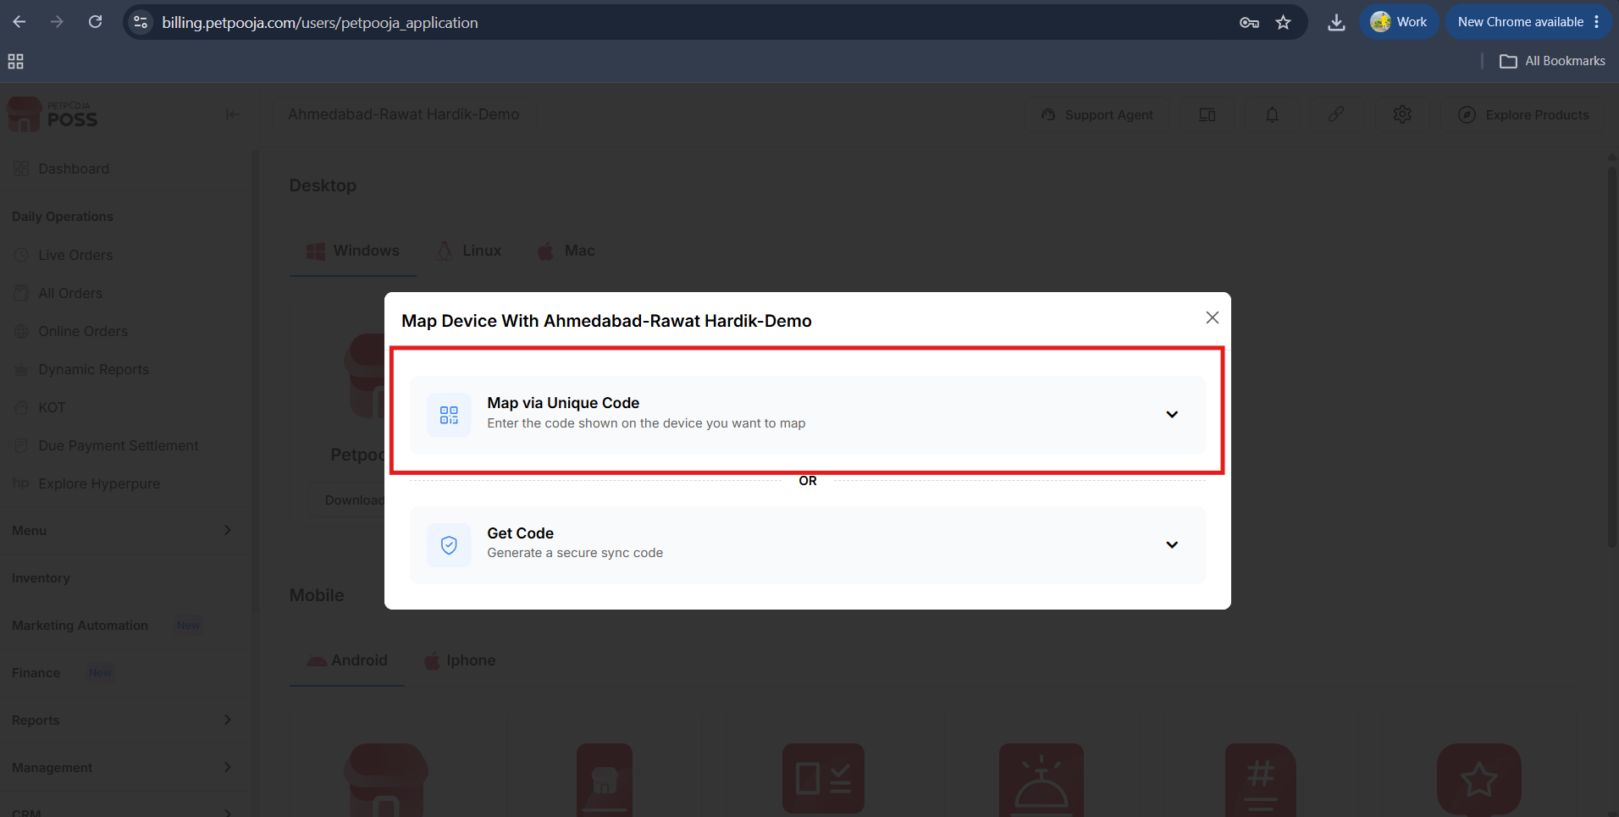
{Image Name: Mapping screen in Dashboard,
Description: The highlighted option show map via unique code option in dashboard screen
Step 5 : After that, click on the arrow icon shown on the screen. Enter the mapping code displayed in the Acceptance App on your mobile. Once you have entered the code, click on the "Map" button. }

